**14/09/2021 CD LAB 2 2019103573**

**EXCERSISES**

**1.Match any string of one or more characters that do not include lower case a-z.**

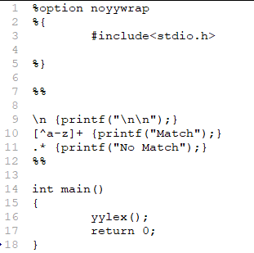**Code :**

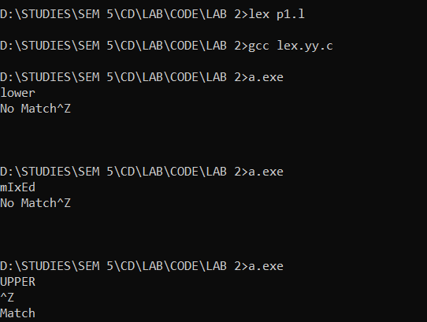**Output :**



**2.Match one or more occurrences ab concatenated**

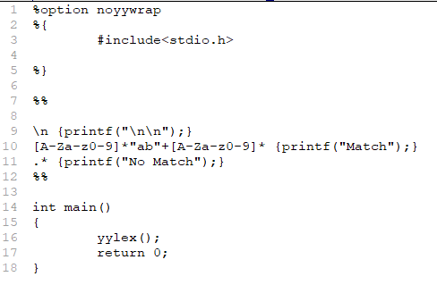**Code :**

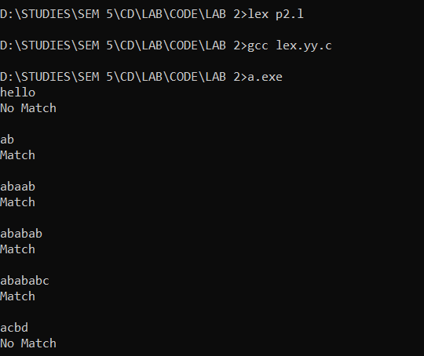**Output :**

**3.Write the LexProgram to find the token and its count from input file for the following.**

**a. Identifier**

**b. number**

**c. Whitespace ( delimiter = space / tab / newline )**

**d. Assignment symbol ( := )**

**e. Operator Symbol ( + , -, *, / )**

**f. Special Character (! ,@ , #, $ , %, ^, &, * , “, ” , ( ) )**

**g. Keyword (if, then, else, for, while, int, float, real)**

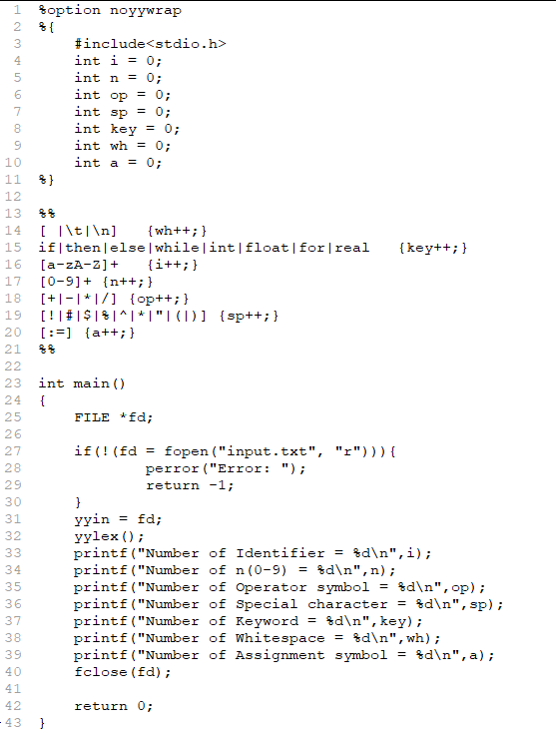**Code :**

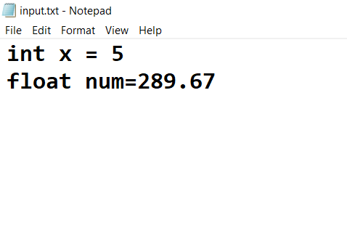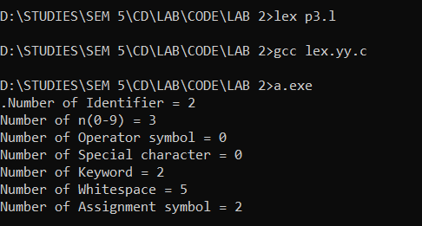**Output :**